**Lesson 03 Demo 08**

**Demo: Creating a Video Using Descript**



**Objective:** To create a short video for a travel company to post on social media

**Tools required:** Descript

**Prerequisites:** None

**Steps to be followed:**

1. Log in to Descript
2. Open a new video project
3. Choose a video from Descript
4. Add script, speaker, and title
5. Publish the video

**Step 1: Log in to Descript**

To proceed with your tasks, visit the official website and either sign up for a new account or log in to your existing Descript account.

<https://web.descript.com/>

**Step 2: Open a new video project**

2.1 Select **Projects** from the left-hand side.

2.2 Click **New** and choose **Video Project.**

**Step 3: Choose a video from Descript**

3.1 Click on the **Media** icon.

3.2 Choose any free video that best suits your requirements.

**Step 4: Add script, speaker, and title**

4.1 Write or paste the script for the video. Now, click on **Add Speaker.**

**Script:**

Embark on unforgettable journeys with our expertly crafted tours and packages. Explore the world with ease and let us turn your dreams into reality. Book your adventure today!

**Note:** You can also write a script using GenAI tools such as ChatGPT.

4.2 Select **Browse stock AI Speakers.**

4.3 Choose a voice from the list shown.

4.4 Add a title to the project.

**Step 5: Publish the video**

5.1 Click on the **Publish** button and confirm **Publish** again.

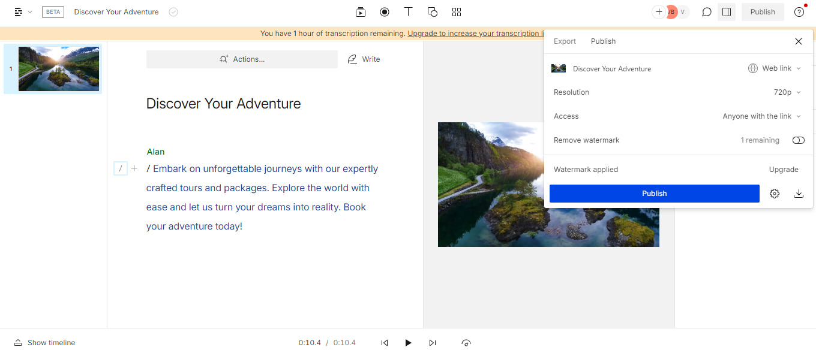

* 1. Click on the **Open share page** icon.

**Output:**

The published video will be available now. You can play, edit, share, and download it.

